**INTEROPERABILITY CURRICULUM**

**SESSION 1**

**Introduction to Interoperability and FHIR Resources**

**INSTRUCTIONS**

• READ THIS DOCUMENT

• STOP AND EXPLORE CONTENT AT THE EMBEDDED LINKS

• ANSWER THE QUESTIONS

**TABLE OF CONTENTS**

A. WHAT IS INTEROPERABILITY? 2

B. WHY IS INCREASING HEALTH DATA INTEROPERABILITY IMPORTANT? 2

C. WHAT IS THE FAST HEALTH INTEROPERABILITY RESOURCE DATA STANDARD? 3

D. WHAT ARE EXAMPLES OF SOME KEY FHIR RESOURCES? 3

E. WHAT ARE THE ELEMENTS OF THE FHIR PATIENT RESOURCE? 3

F. WHAT ARE THE ELEMENTS OF THE FHIR PROCEDURE RESOURCE? 5

G. WHAT IS AN EXAMPLE OF AN FHIR OBSERVATION RESOURCE? 7

H. WHAT IS AN EXAMPLE OF A FHIR PATIENT RESOURCE? 9

I. WHAT IS AN EXAMPLE OF A FHIR PROCEDURE RESOURCE? 12

J. QUESTIONS 14

K. EXAMPLE OF A PATIENT FHIR RESOURCE IN JSON FORMAT 16

### **WHAT IS INTEROPERABILITY?**

Interoperability has been defined in a number of ways. As examples, consider the following definitions of interoperability:

• The ability of computer systems or software to exchange and make use of information   
 (IGI Global, 2020)

• The ability of different information systems, devices and applications (systems) to access, exchange, integrate and cooperatively use data in a coordinated manner, within and across organizational, regional and national boundaries, to provide timely and seamless portability of information and optimize the health of individuals and populations globally.   
(HIMSS, 2020)

• The ability of diverse information systems to seamlessly share data and coordinate on tasks involving multiple systems.

(Braunstein, 2018)

The bottom line is this. Health IT systems developed by different teams at different times need to be able to communicate with each other. The degree of interoperability between two systems tells us the degree to which those two systems can communicate and coordinate their functions.

### **WHY IS INCREASING HEALTH DATA INTEROPERABILITY IMPORTANT?**

Increased health IT interoperability is linked to making gains towards the Triple Aim. The Triple Aim includes work to do these three things at once:

* Improve population health outcomes and decreased health disparities
* Decrease the costs of care and health promotion
* Improve the experience of receiving care

### **WHAT IS THE FAST HEALTH INTEROPERABILITY RESOURCE (FHIR) DATA STANDARD?**

* It provides a means for representing and sharing information among clinicians and organizations in a standard way regardless of the ways local EHRs represent or store the data (eCQI)
* It details the exchange of protected health information among healthcare professionals. This includes diagnostic data, clinical health data and any administrative information (Continuum,2020)

### **WHAT ARE EXAMPLES OF SOME KEY FHIR RESOURCES?**

* Patient - <https://www.hl7.org/fhir/patient.html>
* Procedure - <https://www.hl7.org/fhir/procedure.html>
* Encounter - <https://www.hl7.org/fhir/encounter.html>
* Appointment - <https://www.hl7.org/fhir/appointment.html>
* Observation - <https://www.hl7.org/fhir/observation.html>
* Condition - <https://www.hl7.org/fhir/condition.html>
* Slot - <https://www.hl7.org/fhir/slot.html>
* Medication - <https://www.hl7.org/fhir/medication.html>
* Location - <https://www.hl7.org/fhir/location.html>
* Immunization - <https://www.hl7.org/fhir/immunization.html>

### **WHAT ARE THE ELEMENTS OF THE FHIR PATIENT RESOURCE IN DETAIL?**

To see the elements of the FHIR Patient resource, we can use the HL7 FHIR Resource webpage as a starting point.

Take the following steps to see the elements of the **Patient resource**:

Step 1: Go to <https://www.hl7.org/fhir/resourcelist.html>

Step 2: Click on the "Patient resource" link in the Base section of the Resource List

Step 3: Scroll down to see the following list of the elements in the **Patient resource**:

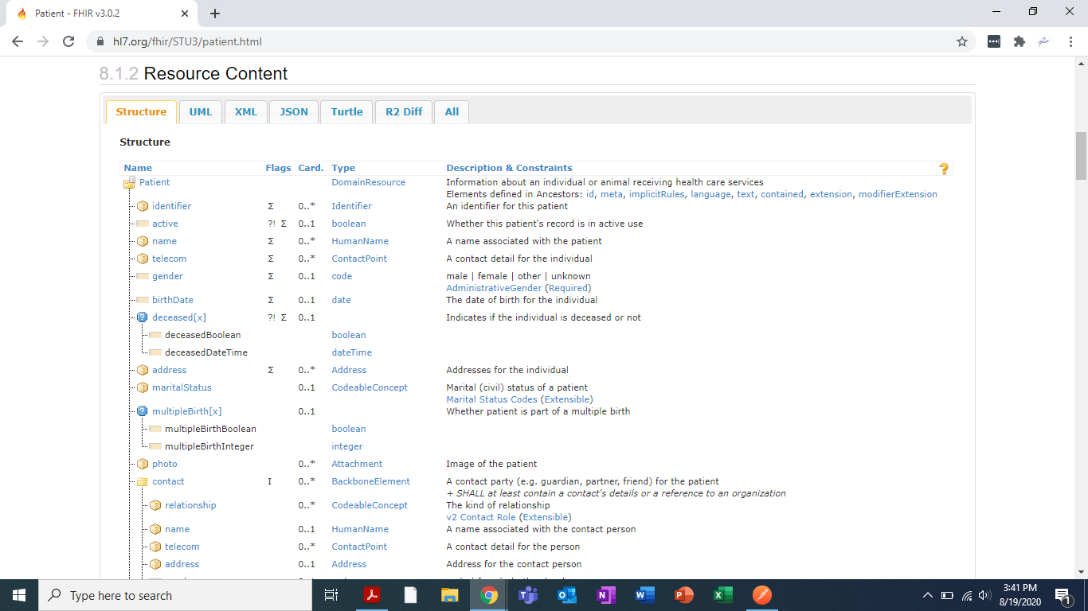

Step 4: Click on the UML tab to see the same elements in a Unified Modeling Language (UML) view:

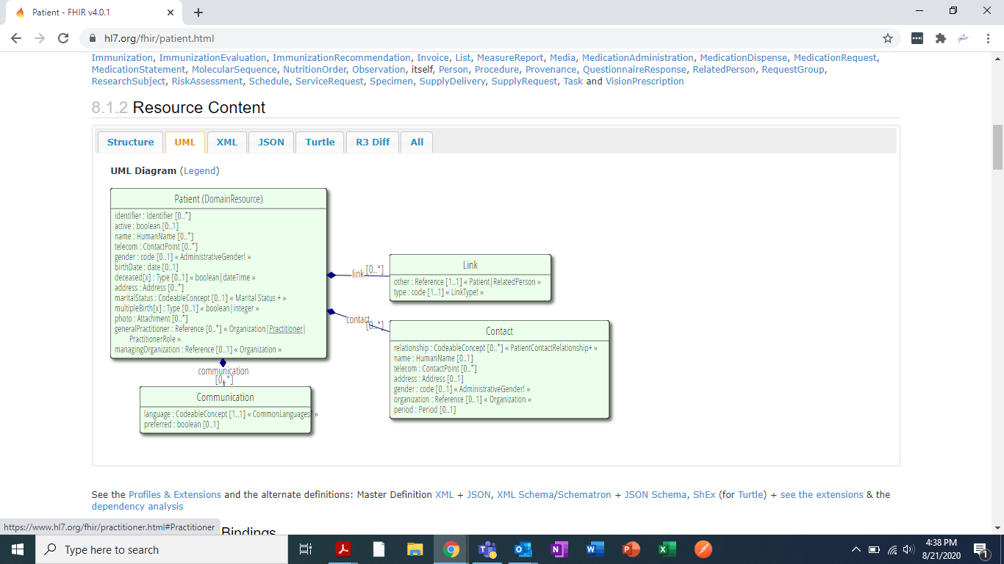

Step 5: Click on the JSON tab to see the same elements for the Patient FHIR resource in JavaScript Object NOtation (JSON) format:

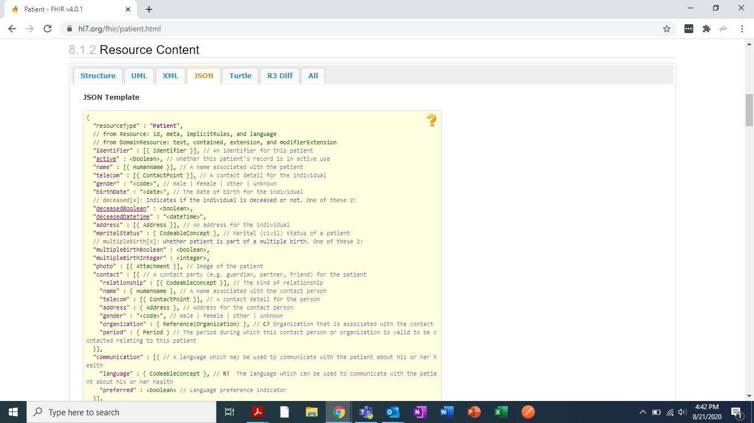

### **WHAT ARE THE ELEMENTS OF THE FHIR PROCEDURE RESOURCE IN DETAIL?**

To see the elements of the FHIR Procedure resource, we can use the HL7 FHIR Resource webpage as a starting point.

Take the following steps to see the elements of the Procedure resource:

Step 1: Go to <https://www.hl7.org/fhir/resourcelist.html>

Step 2: Click on the Procedure resource link in the Clinical section of the Resource List

Step 3: Scroll down to see the following list of the elements in the Procedure resource:

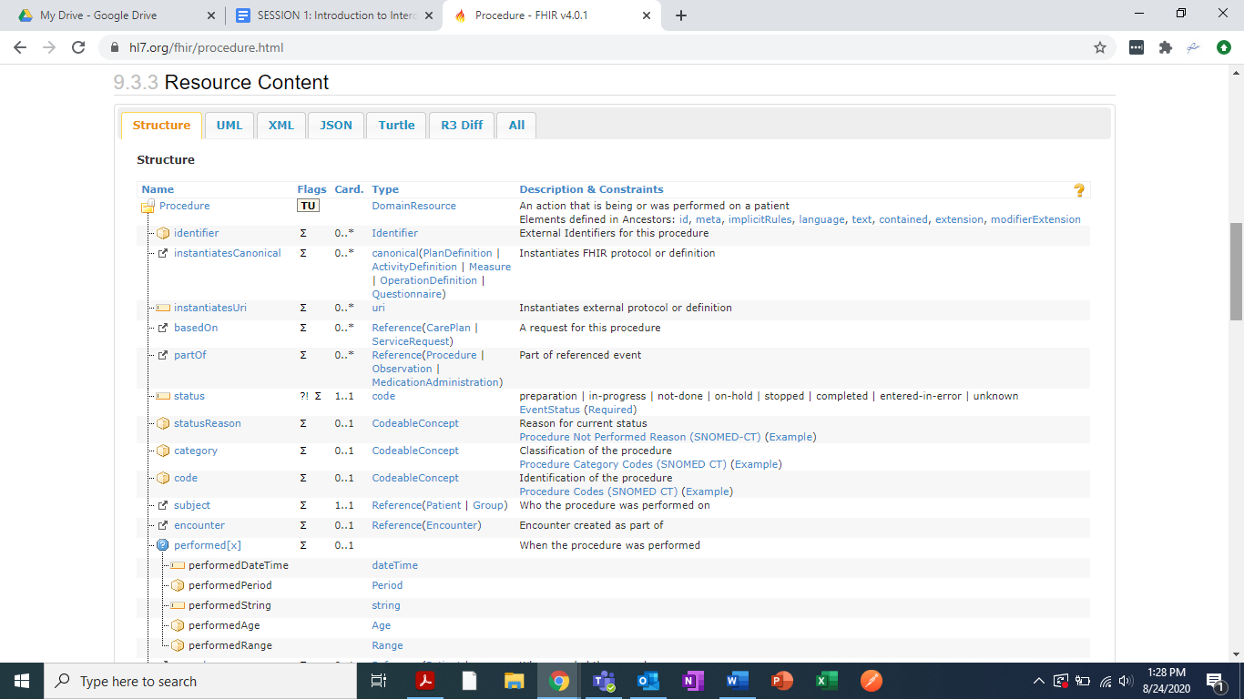

Step 4: Click on the UML tab to see the same elements in a Unified Modeling Language (UML) view:

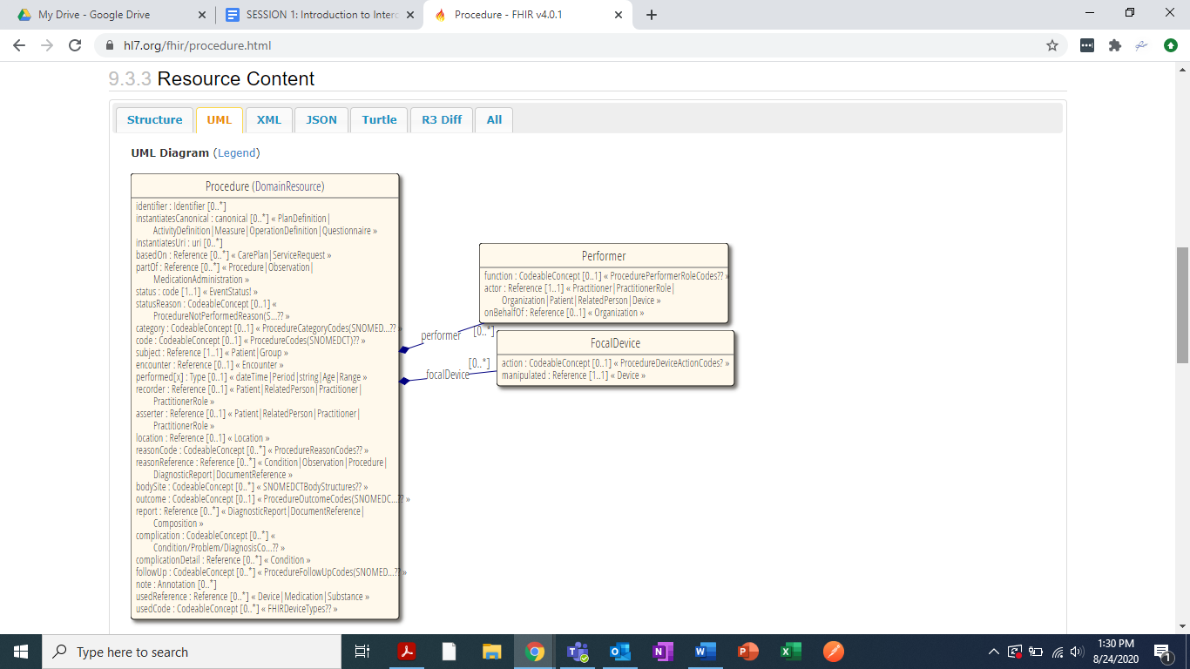

Step 5: Click on the JSON tab to see the same elements for the Procedure FHIR resource in JavaScript Object NOtation (JSON) format:

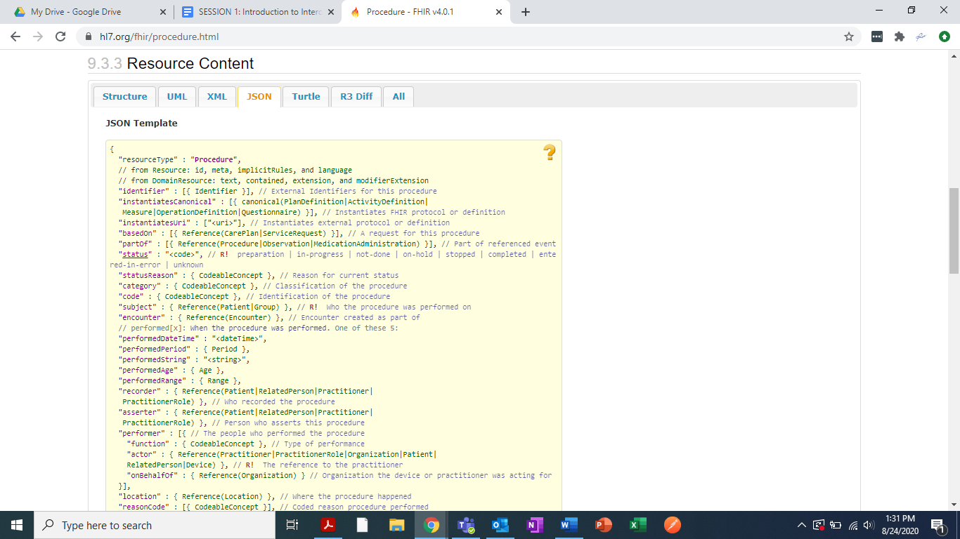

### **WHAT ARE THE ELEMENT DETAILS OF AN INSTANCE OF AN FHIR OBSERVATION RESOURCE?**

To see the element details of an instance of the FHIR Observation resource, we can use the HL7 FHIR Resource webpage as a starting point.

Take the following steps to see the element details of an instance of the Observation resource:

Step 1: Go to <https://www.hl7.org/fhir/resourcelist.html>

Step 2: Click on the Observation resource link in the Clinical section of the Resource List

Step 3: Click on the Detailed Descriptions tab to see the following list of the elements on an instance in the Observation resource and scroll down to find the specified element details:

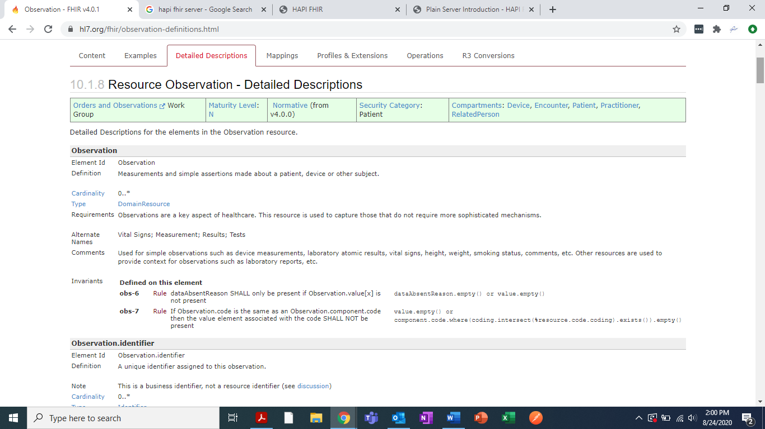

**NEXT** . . . for another view of this resource try:

Step 1: Go to <https://www.hl7.org/fhir/resourcelist.html>

Step 2: Click on the Observation resource link in the Clinical section of the Resource List

Step 3: Scroll down to see the following list of the elements in the Observation resource:

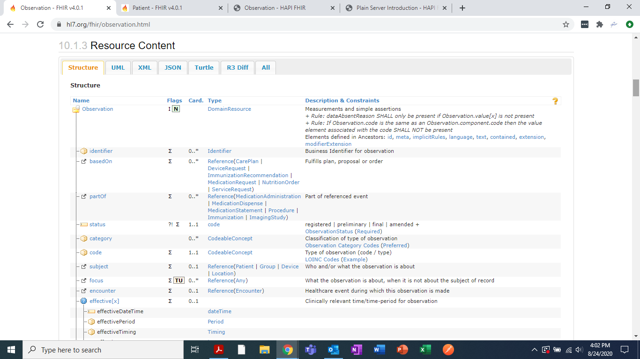

Step 4: Double click on the element under review for example code to view the code details:

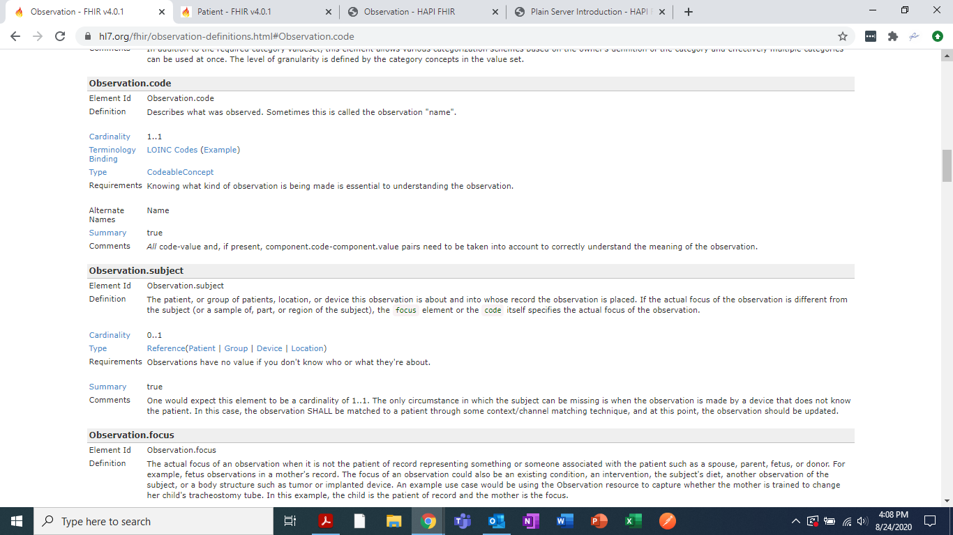

### **WHAT ARE THE ELEMENTS OF AN INSTANCE IN A FHIR PATIENT RESOURCE?**

To see the element details of an instance of the FHIR Patient resource, we can use the HL7 FHIR Resource webpage as a starting point.

Take the following steps to see the element details of an instance of the Patient resource:

Step 1: Go to <https://www.hl7.org/fhir/resourcelist.html>

Step 2: Click on the Patient resource link in the Base section of the Resource List

Step 3: Click on the Detailed Descriptions tab to see the following list of the elements on an instance in the Patient resource and scroll down to find the specified element details:

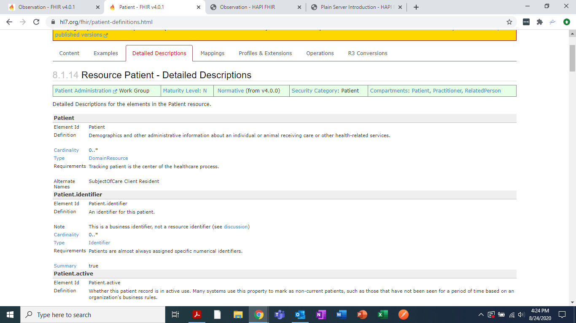

**NEXT** . . . for another view of this resource try:

Step 1: Go to <https://www.hl7.org/fhir/resourcelist.html>

Step 2: Click on the Patient resource link in the Base section of the Resource List

Step 3: Scroll down to see the following list of the elements in the Patient resource:

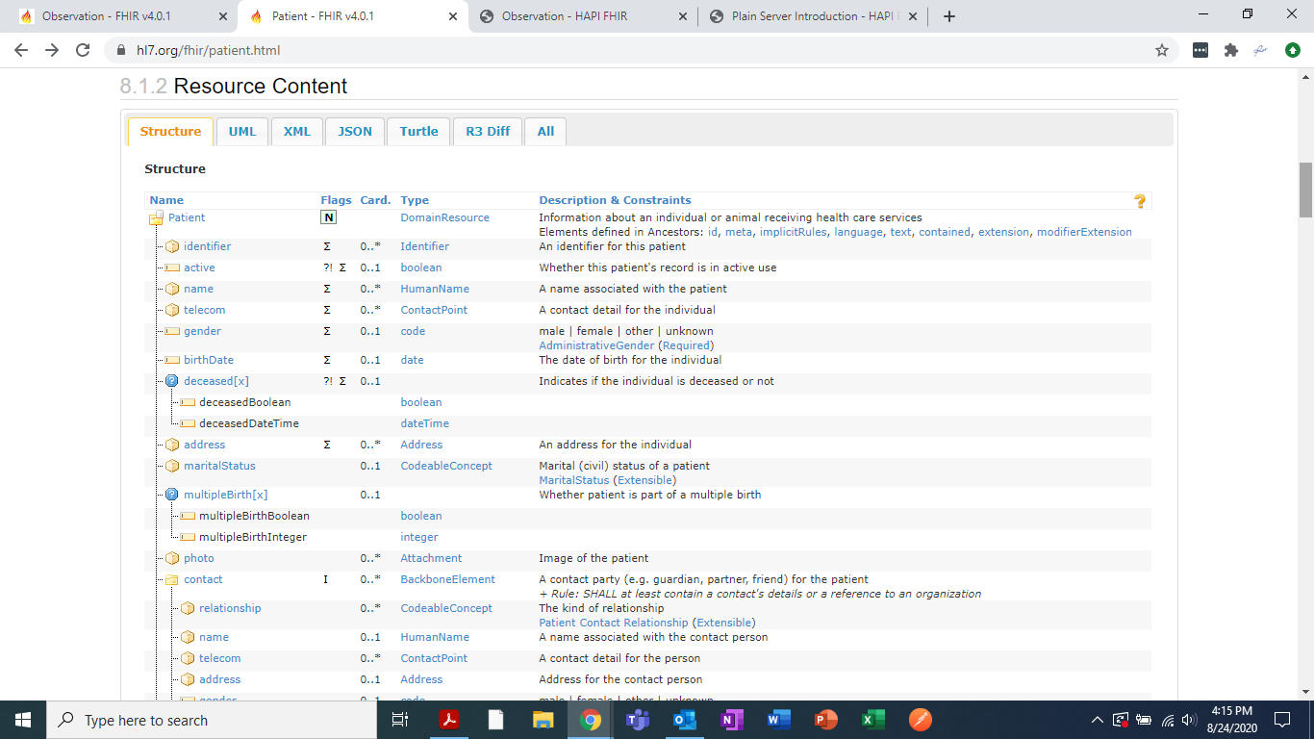

Step 5: Double click on the element under review for example patient.name to view the patient.name details:

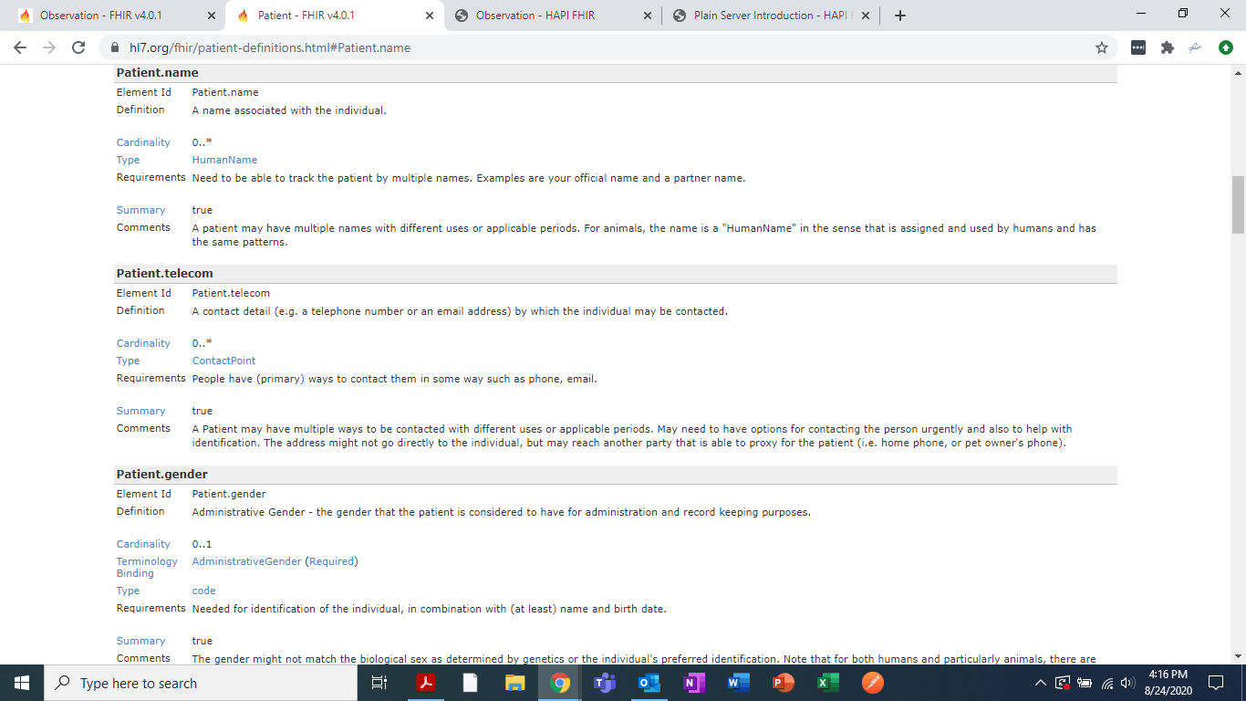

### **WHAT ARE THE ELEMENTS OF AN INSTANCE IN A FHIR PROCEDURE RESOURCE?**

To see the element details of an instance of the FHIR Procedure resource, we can use the HL7 FHIR Resource webpage as a starting point.

Take the following steps to see the element details of an instance of the Procedure resource:

Step 1: Go to <https://www.hl7.org/fhir/resourcelist.html>

Step 2: Click on the Procedure resource link in the Clinical section of the Resource List

Step 3: Click on the Detailed Descriptions tab to see the following list of the elements on an instance in the Procedure resource and scroll down to find the specified element details:

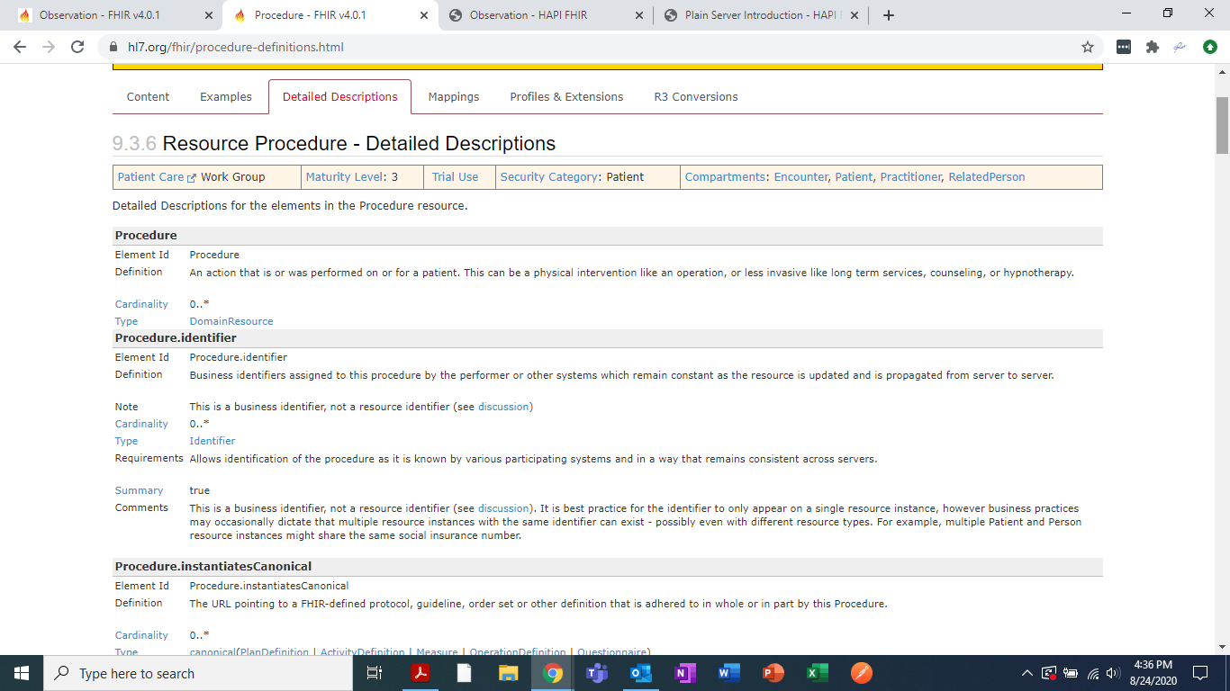

**NEXT** . . . for another view of this resource try:

Step 1: Go to <https://www.hl7.org/fhir/resourcelist.html>

Step 2: Click on the Procedure resource link in the Clinical section of the Resource List

Step 3: Scroll down to see the following list of the elements in the Procedure resource:

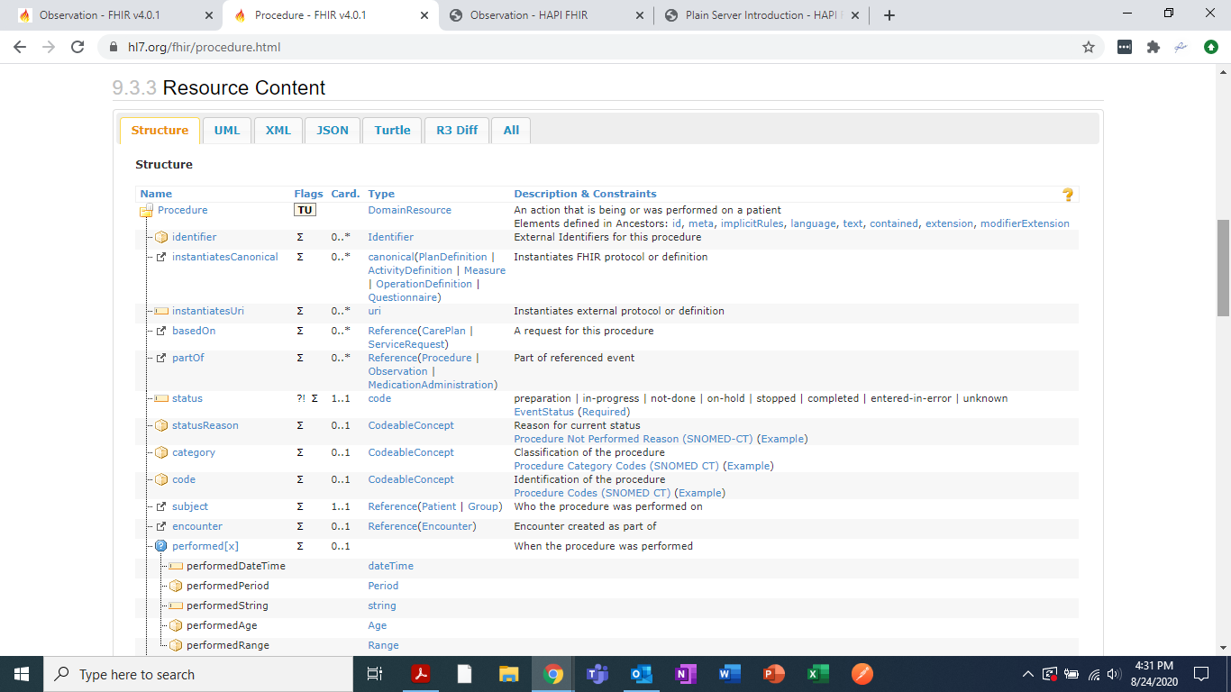

Step 4: Double click on the element under review for example procedure.identifier to view the procedure.identifier details:

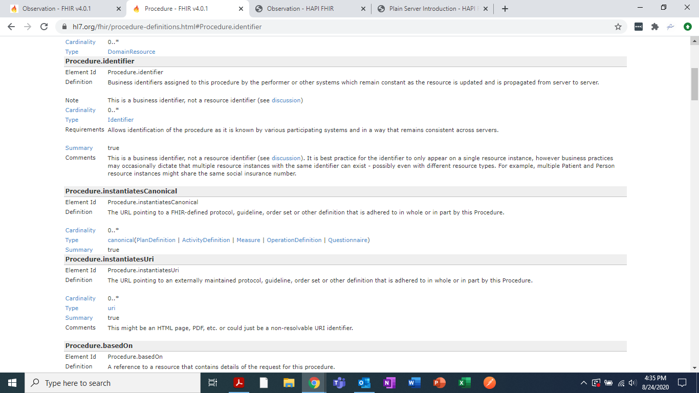

### **QUESTIONS TO TEST YOUR KNOWLEDGE**

1. How might FHIR resources that standardize the ways different elements of health data are represented IMPROVE interoperability between health IT systems?

**Your answer here**

1. Consider the content of the Patient FHIR resource. Approximately how many facts about a single person can be included in one FHIR patient domain resource? (See the UML diagram below to help answer this question.)

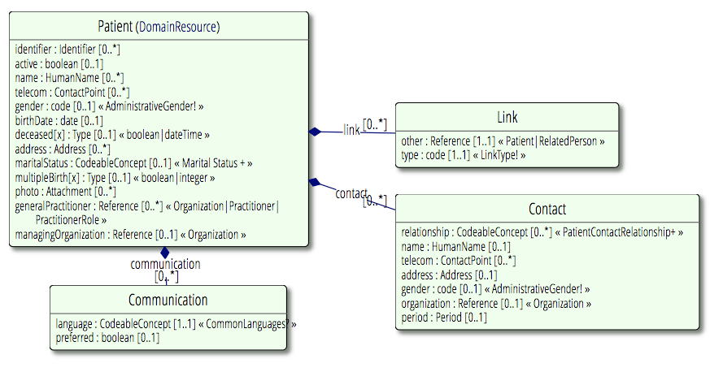

**Your answer here**

1. Below on the next two pages is an actual example of a FHIR Patient resource in JSON format (this FHIR resource is for a fictitious patient!). See the FHIR resource below in JSON format and then answer these questions, a-d:
   1. What is the patient's first and last name?

**Your answer here**

* 1. What is the patient's mobile phone number?

**Your answer here**

* 1. What is the patient's Social Security Number?

**Your answer here**

* 1. Do you think that a computer program could be written to extract the first and last name, mobile phone number, and Social Security Number from the FHIR resource below automatically (Yes or No)? Why or why not?

**Your answer here**

### ***EXAMPLE OF A PATIENT FHIR RESOURCE IN JSON FORMAT:***

**{**

**"resourceType": "Patient",**

**"id": "4",**

**"meta": {**

**"versionId": "1",**

**"lastUpdated": "2020-01-10T20:38:49.000+00:00"**

**},**

**{**

**"url": "http://hl7.org/fhir/us/core/StructureDefinition/us-core-race",**

**"valueCodeableConcept": {**

**"coding": [**

**{**

**"system": "http://hl7.org/fhir/v3/Race",**

**"code": "2056-0",**

**"display": "Black"**

**}**

**]**

**}**

**},**

**{**

**"url": "http://hl7.org/fhir/us/core/StructureDefinition/us-core-ethnicity",**

**"valueCodeableConcept": {**

**"coding": [**

**{**

**"system": "http://hl7.org/fhir/v3/Ethnicity",**

**"code": "2186-5",**

**"display": "Not Hispanic or Latino"**

**}**

**]**

**}**

**},**

**{**

**"url": "http://hl7.org/fhir/us/core/StructureDefinition/us-core-religion",**

**"valueCodeableConcept": {**

**"coding": [**

**{**

**"system": "http://hl7.org/fhir/v3/ReligiousAffiliation",**

**"code": "1077",**

**"display": "Protestant"**

**}**

**]**

**}**

**},**

**{**

**"url": "http://mihin.org/fhir/extension/reference/master",**

**"valueString": "https://~/mihinss/fhir/Patient/3058"**

**}**

**],**

**"identifier": [**

**{**

**"use": "official",**

**"type": {**

**"coding": [**

**{**

**"system": "http://hl7.org/fhir/identifier-type",**

**"code": "SB",**

**"display": "Social Beneficiary Identifier"**

**}**

**]**

**},**

**"system": "http://hl7.org/fhir/sid/us-ssn",**

**"value": "000002875"**

**},**

**{**

**"use": "official",**

**"type": {**

**"coding": [**

**{**

**"system": "http://hl7.org/fhir/identifier-type",**

**"code": "SB",**

**"display": "Social Beneficiary Identifier"**

**}**

**]**

**},**

**"system": "http://mihin.org/fhir/cks",**

**"value": "99d0a46be01a431598646b8990ed06ba"**

**}**

**],**

**"active": true,**

**"name": [**

**{**

**"family": "Vance",**

**"given": [**

**"Esther",**

**"Garrett"**

**]**

**}**

**],**

**"telecom": [**

**{**

**"system": "phone",**

**"value": "616-555-1013",**

**"use": "home"**

**},**

**{**

**"system": "phone",**

**"value": "616-555-7736",**

**"use": "mobile"**

**}**

**],**

**"gender": "female",**

**"birthDate": "1972-06-17",**

**"address": [**

**{**

**"use": "home",**

**"type": "postal",**

**"line": [**

**"66 Third Street"**

**],**

**"city": "Zeeland",**

**"district": "Ottawa County",**

**"state": "MI",**

**"postalCode": "49464"**

**}**

**],**

**"generalPractitioner": [**

**{**

**"reference": "Practitioner/1",**

**"display": "Dana Myrtle Foley MD"**

**}**

**]**

**}**

**REFERENCES:**

IGI Global

Casiraghi, S., & Calvi, A. (2020). Biometric Data in the EU (Reformed) Data Protection Framework and Border Management: A Step Forward or an Unsatisfactory Move?. In *Personal Data Protection and Legal Developments in the European Union* (pp. 202-223). IGI Global.

HIMSS

Healthcare Information and Management Systems Society. (2020, November 6). *Interoperability in Healthcare*.

<https://www.himss.org/resources/interoperability-healthcare>

Braunstein book

Braunstein, M. L. (2018). *Health Informatics on FHIR: How HL7's New API is Transforming Healthcare*. Springer International Publishing.

eCQI

Fast Healthcare Interoperability Resources® (FHIR) | eCQI Resource Center. *Fast Healthcare Interoperability Resources® (FHIR).*

<https://ecqi.healthit.gov/fhir>

Continuum

Continuum. (September 16, 2020). *What is FHIR (Fast Healthcare Interoperability Resources)?*

<https://www.carecloud.com/continuum/what-is-fhir-fast-healthcare-interoperability-resources/>